DIOCESE OF RAPHOE

Safeguarding
Adults at Risk

Diocesan Guidelines for Clergy, Staff and Volunteers
Updated: January 2019

Raphoe Safeguarding Services
Diocesan Pastoral Centre
Letterkenny
Co. Donegal.
Tel: 074 9125669
www.raphoediocese.ie

A Vulnerable Person is and adult who may be restricted in capacity to guard himself / herself against harm or exploitation or to report such harm or exploitation.
Restriction of capacity may arise as a result of physical or intellectual impairment. Vulnerability to abuse is influenced by both context and individual circumstances.
(HSE, Safeguarding Vulnerable Persons at Risk of Abuse, National Policy & Procedures, Social Care Division – December2014)
Key principles in vulnerable adult protection and welfare
Citizenship confers a status on an individual whereby their fundamental right to dignity and respect and other basic human rights as well as their rights to participation in society are upheld and supported by the Constitution, by Ireland’s human rights treaty commitments and by the laws of the State.

Contents |  | Page No.
Foreword | Bishop of Raphoe | 4
Section 1 | Introduction | 5
Section 2 | Guiding Principles | 6
Section 3 | Legal Framework | 9
Section 4 | Recruitment & Selection | 11
Section 5 | Recognising Abuse | 13
Section 6 | Recording & Reporting | 16
Section 7 | Inter-Agency Cooperation and Sharing of Information | 19
Section 8 | Role of the Designated Liaison Person | 20
Section 9 | Record Keeping & Confidentiality | 21
Section 10 | Bibliography | 22
Appendix I | Recruitment Forms | 25
Appendix II | Role of the Eucharistic Minister to the Housebound | 35
Appendix III | Code of Conduct for Those who Minister to Vulnerable Adults | 37
Appendix IV | Reporting Form | 39
Appendix V | Access to Advice and Support | 43
Appendix VI | Whistle-blowing Policy | 45

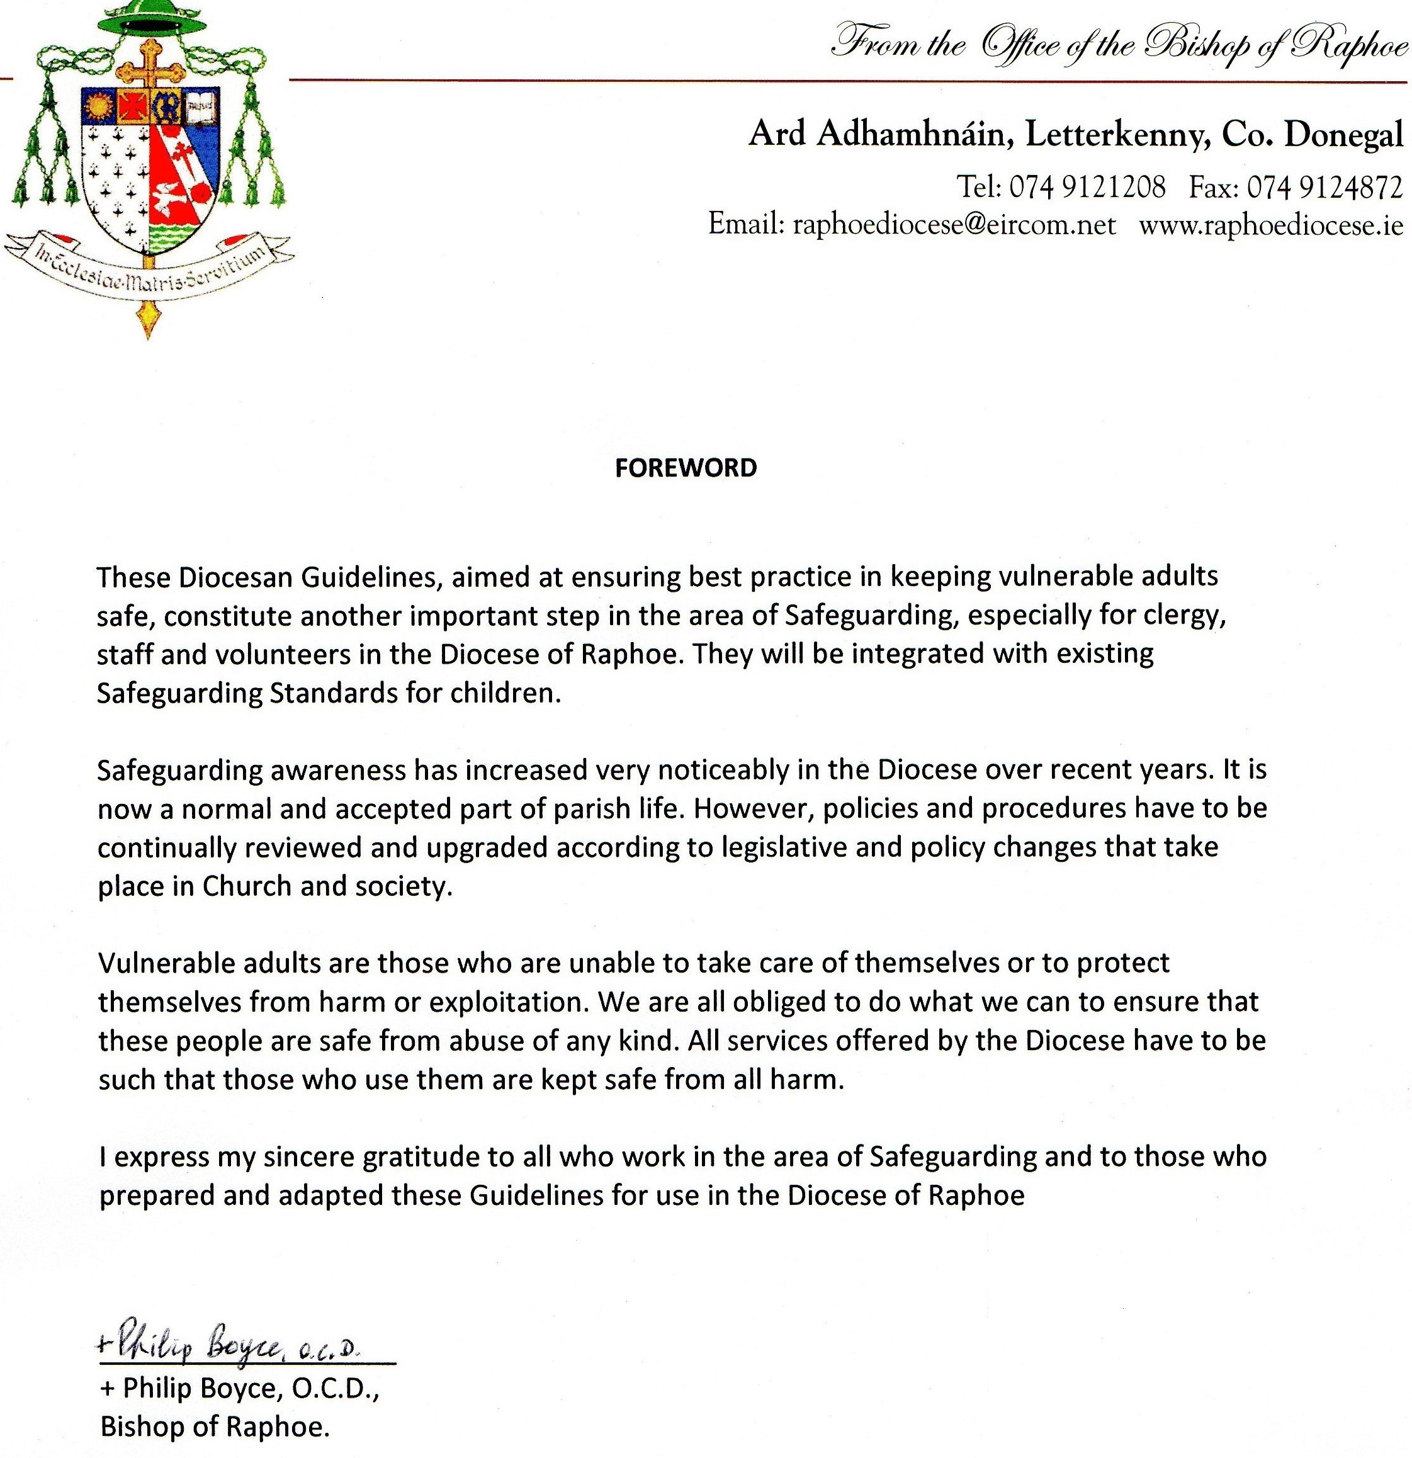

Section 1: Introduction

The Diocese recognises that there are many people with whom Church personnel have contact who require special care and attention. The Diocese values and encourages the participation of vulnerable adults in all parish liturgies and activities that enhance their spiritual, physical, emotional, intellectual and social development. We believe that all Church personnel, including priests, religious, staff and volunteers must carry out their ministry respecting the rights of the individual in line with the gospel values and human rights legislation.
The Diocese recognises and upholds the dignity and rights of vulnerable adults and is committed to safeguarding all our members. The guidance set out in this document provides a framework of how the Diocese ministers to vulnerable adults. It identifies what we mean by the term “vulnerable adult” and highlights values and principles which should underpin such ministry.
These guidelines apply to all clergy, staff, volunteers and religious (both diocesan and visiting), and adhere to current practice and guidance in the Republic of Ireland. They should be read in conjunction with the Diocesan Safeguarding Policy and Procedures available on the Diocesan website (www.raphoediocese.ie).
External/independent groups/organisations, seeking to hire or lease Diocesan/parish property to deliver their own service/activity (involving vulnerable adults) will be made aware of the Diocesan Safeguarding Vulnerable Adults Guidelines, but will also be expected to meet certain requirements before an agreement of lease or rental of property is made.

The Diocese, through these guidelines, sets out to protect vulnerable adults from harm and exploitation and to uphold their rights by acting in their best interests and with their consent.

These guidelines will be reviewed and amended as required and at least every three years, to take account of any major changes including legislative or policy changes in safeguarding.

Section 2: Guiding Principles –

Safeguarding Vulnerable Adults Statement
The Diocese is committed to safeguarding as an integral component of the life and ministry of the Church and recognises that we have a special responsibility towards all vulnerable people who are members of our faith community.

We want to reassure them, their carers and their advocates that we are committed to creating a safe, caring and compassionate environment for all but especially those parishioners defined as “ vulnerable”.
This commitment is based on Gospel values and teachings and compliance with “best practice.”
The Diocesan Guidelines, when implemented, should ensure the welfare of “ Vulnerable Adults” by:
- Making the welfare of the vulnerable adult a central element of safeguarding;
- Ensuring that these guidelines are supported by robust procedures;
- Implementing the existing procedures for safe recruitment and selection of staff and volunteers to work with vulnerable adults;
- Providing a Code of Conduct/on-going formation materials for Diocesan personnel whose ministry brings them into contact with vulnerable adults;
- Having clear procedures for dealing with and reporting concerns and allegations of abuse;
- Managing personal information and sensitive data, confidentiality and the sharing of information in line with legal requirements;
- Establishing and maintaining links with statutory and voluntary agencies or organisations to ensure “best practice” throughout the Diocese.

Values and Principles
The Diocese’s practice and these Safeguarding Guidelines should be underpinned and guided by a number of values and principles as outlined below:
- Access to information and knowledge
- Choice
- Confidentiality
- Consent
- Dignity and Respect
- Equality and Cultural Diversity
- Independence
- Privacy
- Safety

Consent and Capacity
It is important that clergy, staff and volunteers understand the issues of consent and capacity in order to establish an individual’s ability to give meaningful consent to an act/or situation that may be construed as abusive.
Consent is a clear indication of a willingness to participate in an activity or to accept a service. The vulnerable adult may signal consent verbally, by gesture, by willing participation or in writing. Decisions with more serious consequences will require more formal consideration of consent and appropriate steps should always be taken to ensure that consent is valid.
Clergy, staff and volunteers should remember that no one can give, or withhold consent on behalf of another adult, unless special provision has been made for this, usually in law. In certain situations the need for consent may be overridden. This is generally in the interests of the public to do so, for example, the disclosure of information to prevent a crime or risk to health or life.

Gaining consent from a vulnerable adult
Consent is a process - it results from understanding through dialogue and the provision of information. It may be expressly given or, alternatively, it may be signalled by a person’s conduct. For example, an individual may signal his/her consent to participate in informal situations such as staff party or party in residential home or the weekly parish luncheon club, or by willingly asking a volunteer to assist them in accessing toilet facilities.
As a general rule, the method of gaining consent is likely to be influenced by the seriousness of what is being proposed. The more serious the proposal and the consequences of agreeing to it might require that the vulnerable adult is asked to sign a form. The type of services and activities offered by parishes in the Diocese to vulnerable adults would be unlikely to require written consent. There may, however, be occasions when written consent is required and if clergy have concerns about consent, e.g. as to its validity, they should always seek advice from their Bishop/Superior and/or the Diocesan Safeguarding Co-ordinator. In such circumstances, members of staff or volunteers should always seek advice from their line manager/leader and/or the Diocesan Safeguarding Co-ordinatoir. In such cases the Diocesan Safeguarding Co-ordinator will, in turn, seek professional advice on the matter from the relevant Statutory Authorities. Individuals always have the right to consult directly with statutory agencies.
The important issue is to ensure that the consent given is valid. The consent of a vulnerable adult is considered valid ONLY if:
- He/she has the capacity to consent, i.e. he/she can understand and weigh up the information needed to make the decision;
- Sufficient information has been given to him/her, in an appropriate way, on which to base the decision;
- Consent has been given on a voluntary basis, that is free from coercion or negative influence.

If any of these three factors is absent, consent cannot be considered to be valid.
Circumstances may arise where the vulnerable adult is unable to make decisions for themselves; for example, a learning disability, a severe mental health issue, impaired functioning as a result of a stroke or some form of dementia or any brain injury or trauma which could severely affect his/her intellectual functioning. In these situations, mental capacity, in terms of decision making in respect of treatment, care, care provision, welfare and/or financial assets/ affairs may be impaired.
Legal protections need to be put in place if someone such as a family member, an advocate or health professional has to make decisions for a vulnerable adult who has been deemed to lack capacity.
If clergy, staff or volunteers have any doubts or concerns about whether the consent of a vulnerable adult is valid, or whether he/she has the capacity to do so, they should bring this to the attention of the Diocesan Safeguarding Co-ordinator who will consult with the relevant Social Services Department.

Section 3: Legal Framework - Republic of Ireland
Vulnerable adults are protected against criminal acts in the same way as any other person. Where there is reasonable suspicion that a criminal offence may have occurred, it is the responsibility of the Gardaí to investigate and make decisions about what action should be taken. The Gardaí should always be consulted about criminal matters.

Key relevant legislation within the Republic of Ireland is as follows:

- National Vetting Bureau (Children and Vulnerable Persons) Act 2012*
- Criminal Justice (Withholding of Information of Offences against Children and Vulnerable Persons Act 2012*.
*This legislation has not as yet been enshrined into law but is expected to come before Dáil Ēireann later in 2015.

Definition of a Vulnerable Adult
The current definition of a vulnerable adult within the Republic of Ireland is taken from:
The National Vetting Bureau (Children and Vulnerable Persons) Act 2012 which states:
“Vulnerable Person” means a person, other than a child, who -
- is suffering from a disorder of the mind, whether as a result of mental illness or dementia,
- has an intellectual disability,
- is suffering from a physical impairment, whether as a result of injury, illness or age, or
- has a physical disability,

which is of such a nature or degree—

- as to restrict the capacity of the person to guard himself or herself against harm by another person, or
- that results in the person requiring assistance with the activities of daily living including dressing, eating, walking, washing and bathing.

In addition, the Criminal Justice (Withholding of Information of Offences against Children and Vulnerable Persons) Act 2012 provides for a very similar (but not exactly the same) definition of ‘Vulnerable Person” in the following terms:

“Vulnerable Person” means a person (including, insofar as the offences specified at paragraph 8 of Schedule 2 are concerned, a child aged 17 years old)—

- who—
- is suffering from a disorder of the mind, whether as a result of mental illness or dementia, or
- has an intellectual disability

which is of such a nature or degree as to severely restrict the capacity of the person to guard himself or herself against serious exploitation or abuse, whether physical or sexual, by another person, or

(b) who is suffering from an enduring physical impairment or injury which is of such a nature or degree as to severely restrict the capacity of the person to guard himself or herself against serious exploitation or abuse, whether physical or sexual, by another person or to report such exploitation or abuse to the Garda Síochána or both.

In addition to the legislative definitions above, the Church recognises the need to safeguard other adults who may be in a vulnerable position and who may be in need of pastoral care or be open to exploitation due to their current circumstances e.g. bereavement, relationship breakdown, undergoing counselling etc.

The rights of vulnerable adults to live a life free from neglect, exploitation and abuse are protected under the Human Rights Act 1998. Specifically, a vulnerable adult’s right to life is protected under Article 1; their right to be protected from inhuman and degrading treatment under Article 3; and their right to liberty and security under Article 5.

Section 4: Recruitment and Selection

The Diocese consistently applies a thorough and clearly defined method of recruiting staff and volunteers, involved in a regulated activity, in line with legislative requirements and best practice.

To achieve this the following criteria is used
- Complete an Application Form
- Supply two written references.
- Complete a Declaration Form.
- Produce evidence to verify identification – 2 passport photos.
- Complete a Garda Vetting Form.
- Role Description and Code of Conduct for Those who Minister to Vulnerable Adults.
- Sign a Diocesan Safeguarding Children Policy & Procedures Agreement Form and undergo a Safeguarding Awareness Session.
All the above forms can be found in APPENDIX I and are also available to download at:
www.raphoediocese.ie
National Vetting Bureau (Children and Vulnerable Persons) Act 2012 (not yet commenced).
The National Vetting Bureau (Children and Vulnerable Person) Act 2012 was enacted in December 2012 and was scheduled to commence in November/December 2014. The Act provides a legislative basis for the mandatory vetting of persons who wish to undertake certain work or activities relating to children or vulnerable adults or to provide certain services to children or vulnerable adults.
This act applies to all persons working in a ‘relevant work or activity’ relating to children or vulnerable persons including:
- Pre-schools/schools/centre of education/Home Tutors.
- Hospitals/Special Care Units
- Any work/activity as a minister or any other person engaged in the advancement of religious bodies
- Any work which consists of treatment, therapy or counselling
- Any work that consists of care/supervision of children
- Any work that consists of the provision of advice, guidance or developmental services (including by electronic communication)
Criminal Justice (Withholding of Information on Offences against Children and Vulnerable Persons) Act 2012
A person shall be guilty of an offence under this Act if:
(a) he or she knows or believes that an arrestable offence as listed in the schedule of the Act, has been committed by another person against a child or a vulnerable person and
(b) he or she has information which he or she knows or believes might be of material assistance in securing the apprehension, prosecution or conviction of that other person for that offence, and fails without reasonable excuse to disclose that information as soon as practicable to do so to a member of the Garda Siobhan.
Catholic Church requirements.
In relation to the Church, those who work (paid or unpaid) in a regulated activity will require to be vetted. In addition there are some roles who oversee those in regulated activities who must also be vetted including Bishops and Provincials/Religious Leaders.

Section 5: Recognising Abuse

What is abuse?

Abuse is a violation of an individual’s human and civil rights by any other person or persons. Abuse is defined as: ‘The physical, psychological, emotional, financial or sexual maltreatment or neglect of a vulnerable adult by another person. The abuse may be a single act or repeated over a period of time. It may take one form or a multiple of forms. The lack of appropriate action can also be a form of abuse.

Abuse can occur in a relationship where there is a breach of that trust, who have influence over the life of a dependant, whether they be formal or informal carers, staff or family members or others. It can also occur outside such a relationship’. Department of Health and Social Services Guidance 2006.

Abuse can take many forms including the following:

Physical Abuse

- Including – hitting, slapping, pushing, burning, giving a person medicine that may harm them, restraining or disciplining a person in an inappropriate way.
- Possible signs – fractures, bruising, burns, pain, marks, not wanting to be touched.

Psychological Abuse
- Including – emotional abuse, verbal abuse, humiliation, bullying and the use of threats.
- Possible signs – being withdrawn, too eager to do everything they are asked, showing compulsive behaviour, not being able to things they used to, not being able to concentrate or focus.

Financial or Material Abuse
- Including – misusing or stealing the person’s property, possessions or benefits, cheating them, using them for financial gain, putting pressure on them about wills, property, inheritance or financial transactions.
- Possible signs – having unusual difficulty with finances, not having enough money, being too protective of money and things they own, not paying bills, not normal home comforts.

Sexual Abuse
- Including – direct or indirect sexual activity where the vulnerable adult cannot or does not consent to it.
- Possible signs – physical symptoms including genital itching or soreness or having a sexually transmitted disease, using bad language, not wanting to be touched, behaving in a sexually inappropriate way, changes in appearance.

Neglect or Acts of Omission
- Including – withdrawing or not giving the help that a vulnerable adult needs, so causing them to suffer.
- Possible signs – having pain or discomfort, being very hungry, thirsty or untidy, failing health, changes in behaviour.

Discriminatory Abuse
- Including – the abuse of a person because of their ethnic origin, religion, language, age, sexuality, gender or disability.
- Possible signs – the person not receiving the care services they require, their carer being overly critical or making insulting remarks about the person, the person being made to dress differently from how they wish.

Institutional Abuse
This can happen when an organisation, where the person is living or receiving care from, fails to ensure that the necessary processes and systems are in place to safeguard vulnerable adults and maintain good standards of care and service.
- Including – lack of training of staff and volunteers, lack of or poor quality supervision and management, poor record keeping and liaison with other agencies, low staff morale and high staff turnover.
- Possible signs – vulnerable adult has no personal clothing or possessions, there is no care plan, the person is often admitted to hospital, or there are instances of staff/ volunteers having treated the person badly or unsatisfactorily or acting in a way that causes harm, poor staff morale and high staff turnover and lack of clear lines of accountability and consistency of management.
If there are concerns about a vulnerable adult’s wellbeing which are not dealt with under vulnerable adult safeguarding procedures they should be reported to the local HSE office. A record of this referral should be retained.

Where might abuse take place?
Abuse can happen anywhere:
- In someone’s own home
- In a carer’s home
- Within day care, residential care, nursing care or other institutional settings
- At work or in educational settings
- In rented accommodation or commercial premise
- In public places

Who might abuse?
This could be anyone who has contact with the vulnerable person – it could be a partner, spouse, child, relative, friend, advocate, informal carer, a member of the clergy/ religious order, a healthcare, social care or other worker, a peer or, less commonly, a stranger.

Domestic/Familial Abuse
This is the abuse of a vulnerable adult by a family member such as partner, son, daughter or sibling.

Professional Abuse
The misuse of power and abuse of trust by professionals, the failure of professionals to act on suspected abuse/crimes, poor care practice or neglect in services, resource shortfalls or service pressures that lead to service failure and culpability as a result of poor management systems.
Possible signs of professional abuse include:
- Entering into inappropriate relationships with a vulnerable adult
- Failure to refer disclosure of abuse
- Poor, ill- informed or outmoded care practice
- Failure to support a vulnerable adult to access health/care treatment
- Denying a vulnerable adult access to professional support and services such as advocacy
- Inappropriate response to challenging behaviours
- Failure to whistleblow on issues when internal procedures to highlight issue are exhausted

Peer Abuse
This is the abuse of one vulnerable adult by another vulnerable adult within a care setting. It can occur in group or communal settings, such as day care centres, clubs, residential care homes, nursing homes or other institutional settings.

Stranger Abuse
A vulnerable adult may be abused by someone who they do not know such as a stranger, a member of the public or a person who deliberately targets vulnerable people.
Every organisation should have procedures in place for dealing with concerns raised by staff and volunteers and for reporting those concerns. In the Republic of Ireland (ROI) reports should be made to the relevant HSE Department and/or An Garda Siochana.

Section 6: Recording and Reporting

Everyone is entitled to have their civil and human rights upheld and to live a life free from abuse and neglect. All concerns, allegations and disclosures must be taken seriously and dealt with appropriately.

When there are concerns or where a disclosure or allegation is made, people often feel anxious about passing on the information to someone else. Concerned individuals may ask themselves, “What if I am wrong?” and this may hold them back from taking action. It is important for clergy, staff and volunteers to know that they are not responsible for deciding whether or not abuse has occurred and neither are they responsible for conducting an investigation. This is the role of the appropriate authorities. However, clergy, staff and volunteers do need to pass on any concerns they have – see “Reporting Procedure Flowchart” below which applies to all Diocesan clergy, staff and volunteers.

Reporting Procedure Flowchart
Information Concerning Risk to a Vulnerable Adult

Diocesan Designated Person
Civil Authorities
(i.e. Gardaí, HSE)

Bishop
However, if your ministry involves visiting vulnerable adults in hospitals, residential care homes or other institutional settings, the reporting procedure is through the Designated Person/Manager of the relevant institution.

What would cause you concern or suspicion about abuse?

There are a number of ways in which you might become concerned or suspicious that a vulnerable adult is suffering or, has suffered, harm.

- The vulnerable adult may tell you directly.
- Someone else may tell you of their concerns or some incident that causes you concerns.
- A vulnerable adult may show some signs of physical injury for which there appears to be no credible or satisfactory explanation.
- A vulnerable adult’s demeanour/behaviour may cause you to suspect that something does not feel right, or possible abuse has taken place.
- The behaviour of another individual close to the vulnerable adult makes you feel uncomfortable (this may be another staff member, volunteer, or leader of an activity or family member).
- Through general good neighbourliness and social guardianship.

Being alert to possible abuse plays a significant role in ensuring that vulnerable adults are safeguarded and it is important that all concerns about possible abuse are reported.

What if a vulnerable adult discloses abuse?

Where this happens, it is important that clergy, staff and volunteers know how to respond and do so in accordance with the following guidelines:

DO
- Stay calm
- Listen
- Reassure the person - tell him/her they did the right thing in telling you
- Let them know that the information will be taken seriously and give them information about what will happen next
- If urgent medical/police help is needed, call the emergency services
- Ensure the safety of the person
- Be aware that forensic evidence might be needed
- Let the person know that they will be kept informed at every stage
- Record in writing (date and sign your record) and report to the Designated Liaison Person for the Diocese or if your ministry involves visiting vulnerable adults in hospitals, residential care homes or other institutional settings, the reporting procedure is through the Designated Person/Manager of the relevant institution
- Act without delay

DO NOT
- Stop someone disclosing to you
- Promise to keep secret what they tell you
- Press the person for more details or make them repeat the story
- Gossip about the disclosure or pass any information about this to anyone who does not have a legitimate need to know
- Under any circumstances, contact the alleged abuser
- Attempt to initiate an investigation yourself
- Leave details of your concern on a voicemail or by e-mail
- Delay in responding

Checking Out

There may need to be some initial “checking out” with the vulnerable adult who has disclosed information to you in order to ensure his/her safety. For example, if clergy, staff or a volunteer notices a bruise on a vulnerable adult’s arm, it would be appropriate to ask “I see you have a bruise on your arm. How did that happen?” Then listen. However, be careful not to start investigating.

It is important that clergy, staff and volunteers understand the clear distinction between “checking out” and an investigation. Do not start investigating by asking questions that relate to the detail, or circumstances of the alleged abuse, beyond initial checking out, listening and expressing your concern.

Section 7: Inter-Agency Cooperation &

Sharing of Information

The principles and rights, which have been identified in these Guidelines, can be further strengthened through the promotion of effective Inter-Agency cooperation.
These include the requirements for agencies, both statutory and voluntary, to:
- Work together to protect the rights of vulnerable adults;
- To actively promote the empowerment and well-being of vulnerable adults through the services they provide;
- To work together with the aim of improving the quality of safeguarding work;
- To ensure that best practice in keeping vulnerable adults safe from harm is achieved.
The purpose of Inter- agency cooperation in relation to the protection and safeguarding of vulnerable adults is to ensure that by working cooperatively, a consistent response will be made when concerns are raised or allegations of harm are made.

Sharing of Information
All vulnerable adults and, where appropriate, their carers or advocates, need to be made aware that the operation of multi-disciplinary and inter-agency procedures will, on occasion, require the sharing of information in order to protect a vulnerable adult or others, or to investigate an alleged suspected criminal offence.

Confidential Information Sharing
In normal circumstances, observing the principle of confidentiality will mean that information is only passed on to others with the consent of the service user (‘service user’ means anyone who is a patient or other user of health and / or social service). However, it should be recognised that in order to protect vulnerable adults, it may be necessary, in some circumstances, to share information that might, normally, be regarded as confidential.
The duty to protect takes precedence over individual confidentiality if a person or others are at serious risk of harm or have been seriously harmed. But information sharing will be proportional and on a “ need to know” basis. The person will be advised before the information is shared and with whom it will be shared.

Section 8: Role of the Designated Liaison Person

The Diocesan Designated Persons are appointed by the Bishop and should be widely identified so that everyone knows who to go to if they have a concern regarding the safeguarding of children, including a concern about a child or disclosure of abuse by a child or adult. One way of doing this is to ensure that his/her details are highlighted in parish/congregational websites and on the Policy Statement at the back of all churches.
The Designated Liaison Officer for the Diocese of Raphoe is:

Margaret Northage: 086 2183011
The role of the Designated Liaison Person is:
- to hear any concerns relating to safeguarding children and vulnerable adults, including any disclosures or allegations of abuse, and take responsibility for managing the response to that concern or disclosure, from start to finish. This would include the preliminary internal inquiry and referral to Tusla/HSE / An Garda Síochána and or any subsequent internal investigations. Specific procedures have been drawn up for the Diocesan Designated Person to follow and these can be made available on request;

- to ensure that the person raising a concern, disclosing abuse, or making an allegation and anyone who is implicated are regularly informed about the progress of the inquiry process;

- to carefully record all steps undertaken as part of these procedures.

- Ensure that the vulnerable adult guidelines are followed, particularly in relation to informing the appropriate statutory agencies;
- Ensure that appropriate information is available at the time of the referral to the statutory agencies and that the referral is confirmed in writing, under confidential cover;
- Keep relevant people within the Diocese informed about any action taken and any further action required;
- Ensure that an individual case record is maintained of concerns about the abuse and the action taken by the Diocese, the liaison with other agencies and the outcome;

Section 9: Record Keeping and Confidentiality

Record Keeping
All records relating to concerns/ allegations of suspected or actual abuse of a vulnerable adult/s will be maintained by the Designated Liaison Person in the Diocesan office. Copies of Records and any other relevant information relating to these records should NEVER be stored at parish level. They should be stored securely in the Diocesan office.
Safeguarding records must be kept at least 30 years.
It is the responsibility of the Diocese to ensure that the gathering, storage, usage and sharing of personal information is in line with the requirements of the Data Protection Act, 1998.

Confidentiality
It is important that clergy, staff and volunteers understand the importance of confidentiality. All information relating to concerns/suspicions/allegations about a vulnerable adult should be treated as confidential and should only be communicated on a “need to know” basis. This information should NOT be shared with anyone, inside or outside the Diocese, unless they are involved in the case. Only the relevant personnel need to be involved. The Designated Liaison Person will advise on” who needs to know” and who should have access to records.
While information about vulnerable adults is confidential, it may be disclosed to external agencies to ensure the care and safety of an individual or others or where a crime is suspected. This includes the disclosure of information to An Garda Siochana and the relevant HSE Department for such purposes.
In normal circumstances observing the principle of confidentiality will mean that the information is passed on to others with the consent of the person concerned. However, it should be recognised that in order to safeguard vulnerable adults, it may be necessary, in some circumstances, to share information that might normally be regarded as confidential.
All vulnerable adults, and where appropriate, their carers or representatives need to be made aware that the operation of inter-agency procedures will, on occasion, require the sharing of information in order to safeguard a vulnerable adult or others, or to investigate an alleged or suspected criminal offence.

Section 10: Bibliography

HSE, Safeguarding Vulnerable Persons at Risk of Abuse, National Policy & Procedures, Social Care Division – December2014

Protecting Our Future, Report on the Working Group on Elder Abuse, DoH, 2002 (ROI)

Best Practice Guidance for Voluntary, Not for Profit Organisations and Private Services Providers, HSE, 2012, (ROI).

Open Your Eyes: Protect Yourself from Elder Abuse, HSE, 2014, (ROI).

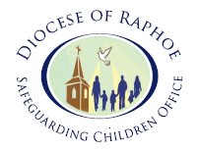

RESOURCES & APPENDICES

APPENDIX I
(available to download at www.raphoediocese.ie ) | Page No.
Application Form | 25
Confidential Reference Form | 27
Declaration Form | 29
Garda Vetting Form | 31
Policy Agreement Form | 33
APPENDIX II:
Role of the Eucharistic Minister to the Housebound | 35
APPENDIX III  Code of Conduct for Those who Minister to Vulnerable Adults | 37
APPENDIX IV  Vulnerable Adult Allegation/Concern Report Form | 39
APPENDIX V:
Access to Advice and Support | 43
APPENDIX VI:
Whistle- Blowing Policy | 45

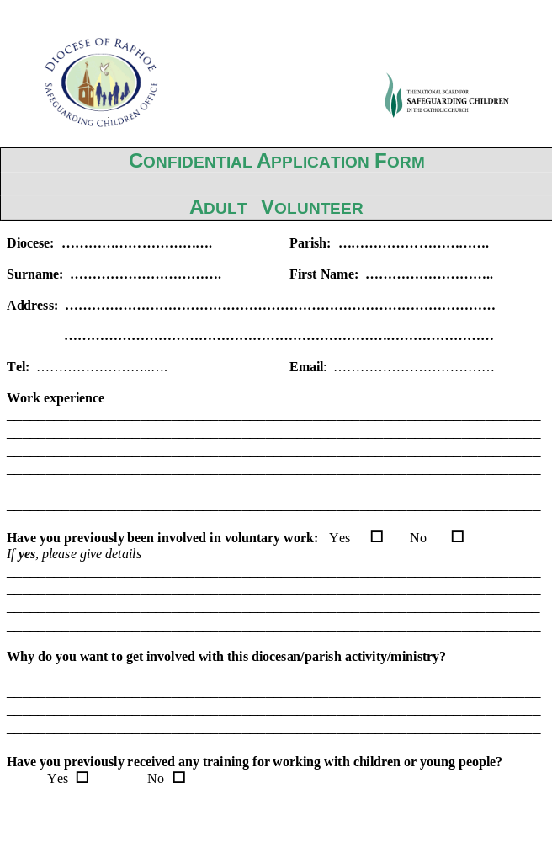 If yes, please give details
_________________________________________________________________________________________________________________________________________________________________________________________________________

Do you agree to participate in the Diocese of Raphoe Safeguarding Children Training before taking up volunteer work with children in church related activities?

Yes □ No □

Is there any medical information we need to be aware of?
_________________________________________________________________________________________________________________________________________________________________________________________________________

Any other relevant information?
_________________________________________________________________________________________________________________________________________________________________________________________________________

Please provide the names and addresses of two people whom we could contact for a reference (not relatives)
Name: | Name:
Address: | Address:
Tel: | Tel:
E-Mail: | E-Mail:

I declare that the above information is true and that I am fit to serve as a volunteer with this parish ministry/activity. I agree to abide by and accept the terms and conditions of participation.

Signed: ………………………………… Date: ……………………

For Office Use

Date form received: ______________ Date Ref forms sent: _________________

Date Ref 1 returned: _____________ Date Ref 2 returned: ____________________

Invited to take up position: yes/no

Signed: _____________________

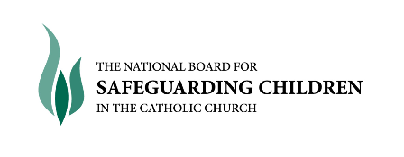

Character and Personal Reference

Confidential

Dear ……………….,

Your name has been given to us by: _________________________

who has applied for the position of: Parish Volunteer

I would appreciate you completing and signing the information below.

Thank you in anticipation of your help.

Yours Sincerely,

………………………….……
Margaret Northage
Diocesan Safeguarding Co-ordinator.

Diocesan Pastoral Centre,
Letterkenny,
Co. Donegal.

Name of Application: _________________________

1) Can you tell us how long you have known the applicant? _______________________

2) In what capacity do you know the applicant?

3) Can you highlight some of the applicant’s skills and qualities?
______________________________________________________________________
______________________________________________________________________

4) Do you, without reservation, recommend the applicant for the position for which they have applied? Please bear in mind that this position involves working with children.

(please tick) Yes: No:

If NO, can you tell us why? ________________________________________________________________
______________________________________________________________________
______________________________________________________________________

If YES, please specify why: _____________________________________________________________________________________________________________________________________________________________________________________________________________________________________________________________________________________________________________________________________

Any additional comments:
______________________________________________________________________

Signed: ……………………………….. Date: ………………………

Please Return Completed Form to: Safeguarding Children Office,
Diocesan Pastoral Centre
Cathedral Square
Letterkenny
Co. Donegal

Declaration form for all persons working as employees or volunteers with children / young people and vulnerable adults.

Confidential
Legislation in both jurisdictions in Ireland, have at their core, the principle that the welfare of children and young people must be the paramount consideration.

Church organisations therefore ask that everyone working or volunteering for the Church, who will come into contact with children or personal details of children, abide by good practice by completing and sign this declaration:

Do you have any prosecutions pending or have you ever been convicted of a criminal offence or been the subject of a Caution or of a Bound Over Order (please tick)

Yes No

If yes, please state below the nature and date(s) of the offence(s)

Date of offence: _______________________________________________________________________

Nature of offence: ______________________________________________________________________________
____________________________________________________________________________________________________________________________________________________________

Have you ever been the subject of disciplinary procedures or been asked to leave employment or voluntary activity due to inappropriate behaviour towards a child?
(Please tick)

Yes No

If yes, please give details including date(s) below:
__________________________________________________________________________________________________________________________________________________________________________________________________________________________________________

Full name (print): ________________________________________________________________________

Any surname previously known by: ________________________________________________________________________

Address: ________________________________________________________________________________________________________________________________________________________________________________________________________________________________________________________________________________________________________________________

Date of birth: __________________ Place of birth: ____________________________

Declaration

I understand that, if it is found that I have withheld information or included any false or misleading information above, I may be removed from my post whether paid or voluntary, without notice. I understand that the information will be kept securely by the Church organisation.

I hereby declare the information I have provided is accurate.

Signed: __________________________________ Date: __________________________


Guidelines for completing Vetting Invitation Form (NVB 1)
Please read the following guidelines before completing this form.
Miscellaneous
The Form must be completed in full using BLOCK CAPITALS and writing must be clear and legible.
The Form should be completed in ball point pen.
Photocopies will not be accepted.
All applicants will be required to provide documents to validate their identity.
- 2 forms of ID required: Either copy of passport or driving license AND a copy of a utility bill or another official document, which is proof of permanent address.
If the applicant is under 18 years of age, a completed NVB 3 - Parent\Guardian Consent Form will be required.
Personal Details
Insert details for each field, allowing one block letter per box.
For Date of Birth field, allow one digit per box.
Please fill in your Email Address, allowing one character/symbol per box. This is required as the invitation to the e-vetting website will be sent to this address.
Please allow one digit per box for your contact number.
The Current Address means the address you are now living at.
The address fields should be completed in full, including Eircode/Postcode. No abbreviations.
Role Being Vetted For
The role being applied for must be clearly stated. Generic terms such as “Volunteer” will not suffice.
Declaration of Application
The applicant must confirm their understanding and acceptance of the two statements by signing the application form at Section 2 and ticking the box provided.

Margaret Northage,  Raphoe Safeguarding Office,  Pastoral Centre,  Monastry Avenue,  Letterkenny,  Co Donegal |  | Your Ref:
 | Vetting Invitation
Under Sec 26(b) of the National Vetting Bureau (Children and Vulnerable Persons) Acts 2012 to 2016, it is an offence to make a false statement for the purpose of obtaining a vetting disclosure.
Section 2 – Additional Information
Forename(s):
Middle Name:
Surname:
Date Of Birth: | D | D | / | M | M | / | Y | Y | Y | Y
Email Address:
Contact Number:
Role Being Vetted For:
Current Address:
Line 1:
Line 2:
Line 3:
Line 4:
Line 5:
Eircode/Postcode:

Name of Organisation/Parish:
I have provided documentation to validate my identity as required and
I consent to the making of this application and to the disclosure of information by the National Vetting Bureau to the Liaison Person pursuant to Section 13(4)(e) National Vetting Bureau (Children and Vulnerable Persons) Acts 2012 to 2016. Please tick box 

Applicant’s
Signature: |  | Date: | D | D | / | M | M | / | Y | Y | Y | Y
Note: Please return this form to the above named.
An invitation to the e-vetting website will then be sent to your Email address.

Safeguarding Policy Agreement

I confirm that I have read and understand the contents of the

Diocese of Raphoe Safeguarding Vulnerable Adults Policy and Procedures.

I agree to abide by and adopt the policy, standards, and procedures in all aspects of my work with the Diocese of Raphoe and to undertake Vulnerable Adults Awareness Training.

Print Name: __________________________

Signed: __________________________

Dated: _____________________________

Role Description of Eucharistic Minister to the Housebound
Job Title: Parish Eucharistic Minister to the Housebound
Responsible to: Parish Priest
Job Purpose: To bring the Eucharist into the residences of housebound people
The main role of the Eucharistic Minister to the Housebound is to bring the Eucharist to the people who are housebound. Parish representatives undertaking this very important role are responsible to the Parish Priest. Their main responsibilities include:
- To bring the Eucharist from the parish church to people in the community who are housebound due to health problems, age or disability;
- To follow the instructions given by the Archdiocese for the reverent conveying of the Eucharist and to follow the appropriate format for the administration of the Eucharist;
- When visiting people either in hospital or in a residential home, to respect the boundaries and regulations of the organisation, particularly by notifying someone in a supervisory position, of your presence in the home;
- To be respectful of the homes of people in the community;
- To be willing to administer the Eucharist prayerfully;
- To be aware of difficulties for some people with swallowing the Eucharist and therefore accommodating the size of the portion of the Host to enable comfortable reception of the Sacrament. It is essential to adhere to guidance from medical staff in relation to health issues e.g. people who are peg fed cannot receive the Eucharist;
- To be sensitive to the fact that doctors, nurses or social services may call just before or whilst the Sacrament is being administered and that medical care should take precedence;
- Willingness to talk with people to whom the Sacrament is being brought, recognising them as part of the Body of Christ;
- Ensure that the Eucharistic Minister has an awareness and adheres to the Diocesan Safeguarding Policy and Procedures.
Person Specification
- To be a person of integrity and good character;
- To have reverence for the Eucharist;
- To have a clear understanding of the Eucharist as a Sacrament of unity, reconciliation and healing;
- Full acceptance of the Church’s teaching on the Eucharist and the Mass;
- To be available to bring the Eucharist on a regular basis to those in need;
- To recognise that Jesus is present in the Eucharist and in the people to whom the Eucharist is being given;
- To be able to maintain confidentiality in relation to people’s personal details and information.

Note: We recognise in the case of close relatives who live at the same address as the housebound or close family members e.g. children/niece/nephew/grandchildren or siblings, there is an exception from the normal vetting requirements as no additional access is created in such cases.

Code of Conduct for Those who Minister to Vulnerable Adults
Ministry with vulnerable adults is a gift from God. It is critical that boundaries are respected and that thoughtful relationships are established which always place the needs and well-being of the vulnerable adult as the primary concern. Those carrying out ministries should have clearly defined codes of conduct. A balance needs to be struck between the right to protection and the need to allow appropriate spiritual relationships between an individual and his/her priest, lay minister or volunteer. It is important for all clergy, staff and volunteers to:
- Adhere to the protocols and guidelines of any organisation whose premises they are ministering within;
- Treat everyone equally with respect;
- Engage and interact appropriately with vulnerable adults;
- Be aware of the difficulties posed by language barriers and other communication difficulties;
- Respect the dignity of each individual and their right to personal privacy;
- Recognise that particular care is required in moments when you may be discussing sensitive issues with vulnerable adults;
- Avoid situations that might compromise your relationship with vulnerable adults, and which are unacceptable within a relationship of trust. This rule should apply to all such behaviours including those which would constitute an illegal act;
- Respect the religious, cultural, racial and sexual orientation of the vulnerable adult and be open to and aware of diversity in their beliefs and practices and those of their families;
- Provide an example of good conduct you wish others to follow;
- Operate within Diocesan Guidelines.

The Code outlines unacceptable behaviours. Clergy, staff and volunteers must never:

- Physically or emotionally abuse or exploit a vulnerable adult;
- Become involved in either using the vulnerable adult’s money on his/her behalf or in giving the vulnerable adult advice in use of his/her money;
- Use language, make suggestions or offer advice which is inappropriate, offensive or abusive;
- Do things of a personal nature for a vulnerable adult that he/she is capable of doing for his/herself or are the responsibility of their family or carer;
- Act in ways intended to shame, humiliate, belittle or degrade;
- Discriminate against the person on the basis of religion, race, culture, gender or sexual orientation;
- Form inappropriate relationships with vulnerable adults;
- Gossip about personal details of vulnerable adults and their families;
- Photograph or video a vulnerable adult.
Clergy, staff and volunteers are being made aware of the Code in the expectation that they will act in accordance with it when exercising ministry to the vulnerable.

Vulnerable Adult Allegation/Concern Report Form

Vulnerable Adult Allegation/Concern Report Form
Name of Parish/Organisation

Name of Vulnerable Adult
Age/Date of Birth
Gender
Names of carers (if known)

Home Address (if known)
Please complete those sections below that are relevant
- Disclosure by a vulnerable adult

When was the disclosure made (dates and times)?

Who did the vulnerable adult make the disclosure to?
What did the vulnerable adult actually say?
- Indicators

Describe any signs or indications of abuse (with times and dates)
Has the vulnerable adult alleged that any particular person is the abuser? (if so, please record details and the relationship, if any, to the vulnerable adult below)
- Concerns expressed by another person about a vulnerable adult

Record the concerns that were passed to you (with dates and times) and if possible ask the person who expressed the concerns to confirm that the details as written are correct
- Details of any immediate action take e.g. first aid, etc.
- Has the vulnerable adult expressed any reservations about you talking to the Designated Liaison Person about the matter?
- Does the vulnerable adult have any particular needs e.g. communication, etc.?

Signatures

To be signed by the person reporting the concern

Name:
Job Title:

Signed:

Date:

Date received and actioned by Designated Liaison Person:

Name:

Signed:

Date:

Action taken by Designated Liaison Person

Signed:

Date:

ACCESS TO ADVICE AND SUPPORT
An Garda Síochána should be contacted through the National Bureau of Criminal Investigations in Harcourt Square, Dublin 2. This is the central office for the investigation of child protection concerns. All allegations are processed through the central team who in turn decide whether to allocate to the local Garda for investigation.
Telephone: 00353 1 6663436

The HSE has a dedicated Elder Abuse Service, with Senior Case Workers now working in most Local Health Office Areas. You can also seek advice from the HSE Information Line:
Monday to Saturday 8am – 8pm Call Save: 1850 24 1850 or Email: info@hse.ie
Local HSE Office: Letterkenny 074 91 23672
074 91 23770
Donegal Town 074 97 23540
Buncrana 074 93 20420
Towards Healing Freephone: 1800 303416
“Towards Healing” is a private and confidential counselling and support service for survivors of institutional, clerical and religious abuse, funded by the Catholic Church in Ireland. The operational hours of the helpline are: Monday and Wednesday (11.00a.m.–8.00p.m.) and Friday (11.00a.m.–4.00p.m.). An answering machine service is available at all other times.
Towards Peace Sister Mary Whyte: Phone: 00353 1 5053028
Mobile 00353 86 7701533

“Towards Peace” offers spiritual support to victims/survivors of clerical abuse whose faith in God may have been affected by their experience. Following initial telephone contact, “Towards Peace” offers an opportunity to talk to a trained spiritual companion in a one-to-one setting and to explore questions and concerns about God, and to get in touch with God's presence in their lives.

The Samaritans Tel: 1850 609090

Diocese of Raphoe
Whistle Blowing Policy
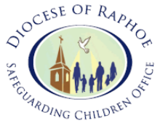

This guidance is written for staff/volunteers of the Diocese of Raphoe (staff/volunteers includes any adult, paid or voluntary, who work directly with children/young people/vulnerable adults) within parish contexts and organisation under the auspices of the Diocese of Raphoe.

Staff/Volunteers must acknowledge their individual responsibility to bring matters of concern to the attention of their supervisor/superior/manager. These could be the Parish Priest, Priest in Charge or Bishop and/or relevant organisation managers. Although this can be difficult this is particularly important where the welfare of children may be at risk.

You may be the first to recognise that something is wrong but may not feel able to express your concerns out of a feeling that this would be disloyal to colleagues or you may fear harassment or victimisation. These feelings, however natural, must never result in a child / young person / vulnerable adult continuing to be unnecessarily at risk. Remember it is often the most vulnerable children or young persons who are targeted. These children need someone like you to safeguard their welfare.

Don't think what if I'm wrong - think what if I’m right

Reasons for whistle blowing:

- • Each individual has a responsibility for raising concerns about unacceptable practice or behaviour
- • To prevent the problem worsening or widening
- • To protect or reduce risks to others
- • To prevent becoming implicated yourself

What stops people from whistle blowing:

- • Fear of starting a chain of events which spirals out of control
- • Disrupting the work or project
- • Fear of getting it wrong
- • Fear of repercussions or damaging careers
- • Fear of not being believed

How to raise a concern:

- • You should voice your concerns, suspicions or uneasiness as soon as you feel you can. The earlier a concern is expressed the easier and sooner action can be taken.
- • Try to pinpoint exactly what practice is concerning you and why.
- • Approach your immediate superior/supervisor/manager.
- • If your concern is about your immediate superior/supervisor/manager then please contact either one of our Designated Persons or externally the National Office for Safeguarding Children in the Catholic Church. Contact details are below for all of these.
- • Make sure you get a satisfactory response - don't let matters rest.
- • Ideally, you should put your concerns in writing, outlining the background and history, giving names, dates and places wherever you can.
- • A Staff member or Volunteer is not expected to prove the truth of an allegation but will need to demonstrate sufficient grounds for the concern.

What happens next?

- You should be given information on the nature and progress of any enquiries.
- Your supervisor/superior/manager has a responsibility to protect you from harassment or victimisation.
- No action will be taken against you if the concern proves to be unfounded and was raised in good faith. This is in line with the PROTECTION FOR PERSON REPORTING CHILD ABUSE ACT, 1998.
- Malicious allegations may be considered as a disciplinary offence.

- This is also in line with the PROTECTION FOR PERSON REPORTING CHILD ABUSE ACT, 1998.

Further advice and support :

It is recognised that whistle blowing can be difficult and stressful. Advice and support is available from the Diocesan Designated Person and/or the National Office for Safeguarding Children in the Catholic Church in Ireland (Contact details are below).

Name of Designated Officer | Telephone Number
Margaret Northage: | 086 2183011

If you or anyone you know has a concern or wishes to report an allegation directly to the statutory authorities please contact the Local Tusla P{Office and ask to speak to the Duty Social Worker or you may contact An Garda Síochána at the National Bureau of Criminal Investigations in Harcourt Square, Dublin 2.

Tusla – Child & Family Agency | Telephone Number
Letterkenny | 074-9123672/9104714
Donegal Town | 074-9723540
Buncrana | 074-9320420

Garda Síochána via | Telephone Number
National Bureau of Criminal Investigations in Harcourt Square, Dublin 2 | 00353 1 6663436

Remember: Anyone involved in working with children in the Diocese of Raphoe, including the Diocesan Safeguarding Children Personnel can access specialist advice about safeguarding issues from the:

National Board for Safeguarding Children,
New House, St. Patrick’s College,
Maynooth
Co. Kildare

Tel: 01 505 3124.



Living and true God,
You created all that is good and holy.
be close to us your servants,
who gather here today.
Be our constant help and protection.
Enable us to reach out lovingly to all your children,
to show understanding and awareness,
comfort and consolation,
justice and equality.
so that together we may participate fully in parish life and worship.
We ask this through Jesus Christ, your son, our Lord,
who lives and reigns with you and the Holy Spirit,
one God, forever and ever.
Amen.

